JavaScript script to show latest block and transaction:

console.log('The latest block is: ');

console.log(JSON.stringify(eth.getBlock('latest', true), null, '\t'));

console.log('The latest transaction is: ');

for (var i = 0; i < eth.blockNumber; ++i) {

var block = eth.getBlock(eth.blockNumber - i);

if (block.transactions.length > 0) {

console.log(JSON.stringify(eth.getTransaction(block.transactions[0]), null, '\t'));

break;

}

}

After mining, the balance in my account increased.

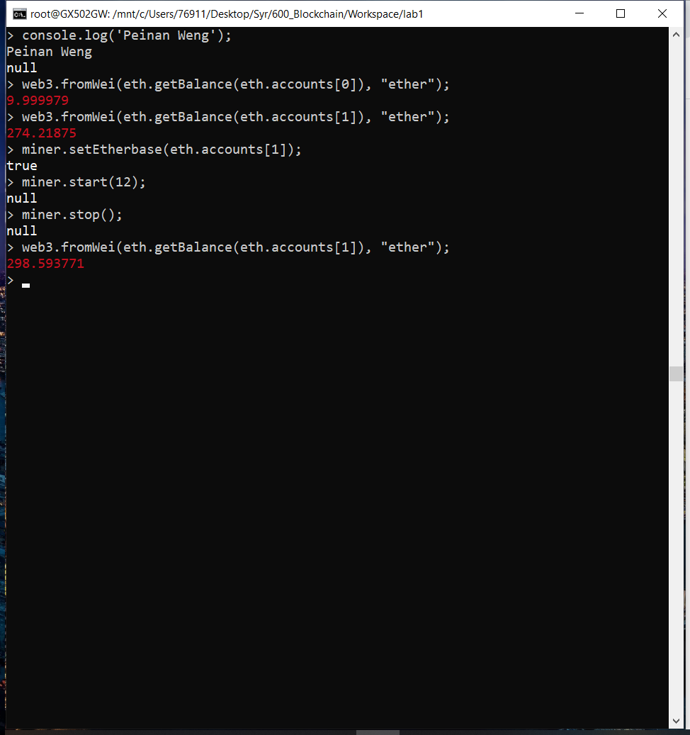

Show the latest block and transaction using script.

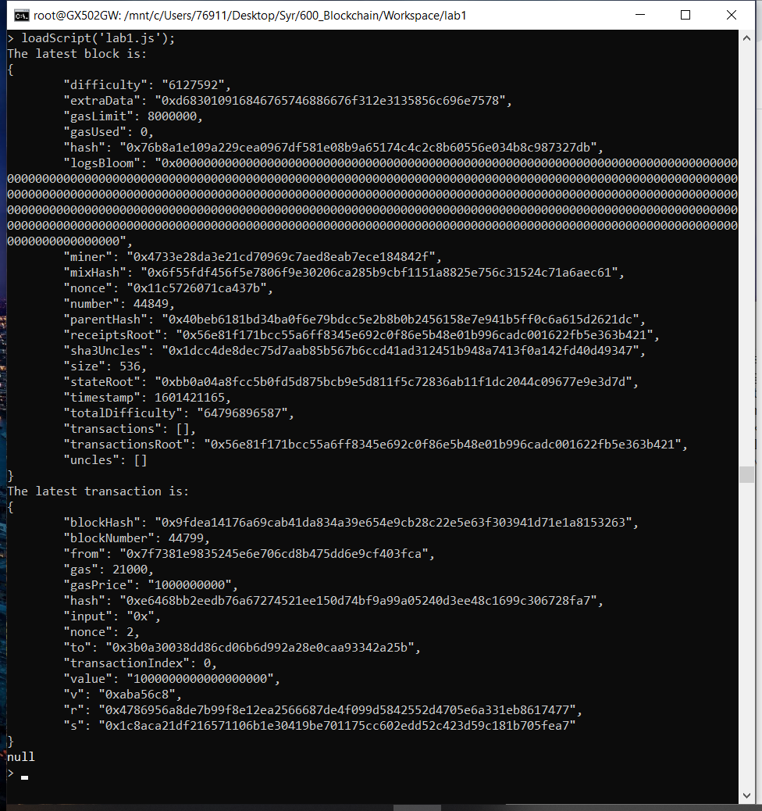

New transaction

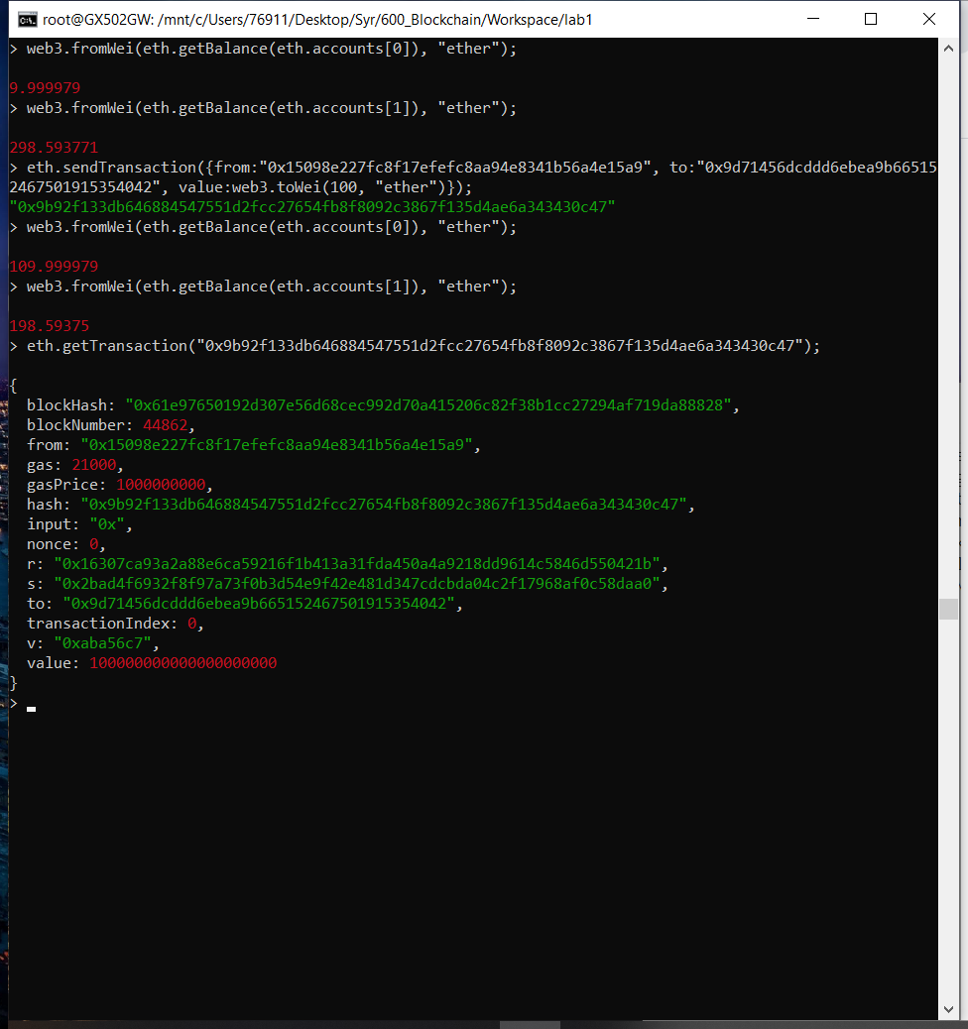

Show the latest block and transaction again after the new transaction has approved. Notice that the latest transaction has changed.

